A.Haque1304$$$$$$

list of html of html css javascript tags which are helpful making codings or projects to all students or teachers & many so on etc

<https://chat.openai.com/share/a34387e7-8e7b-4183-89c6-f25b605b2434>

<https://chat.openai.com/share/a34387e7-8e7b-4183-89c6-f25b605b2434>

<https://chat.openai.com/share/a34387e7-8e7b-4183-89c6-f25b605b2434>

list of npm install or npx create or pip install commands which are helpus to making projects for begginners to advance levels of students which have no time to studing still now a days

<https://chat.openai.com/share/a34387e7-8e7b-4183-89c6-f25b605b2434>

<https://chat.openai.com/share/a34387e7-8e7b-4183-89c6-f25b605b2434>

<https://chat.openai.com/share/a34387e7-8e7b-4183-89c6-f25b605b2434>

such as also panaverse dao live itmate pk code with harry apna college naveed sarwar etc

<https://chat.openai.com/share/a34387e7-8e7b-4183-89c6-f25b605b2434>

<https://chat.openai.com/share/a34387e7-8e7b-4183-89c6-f25b605b2434>

<https://chat.openai.com/share/a34387e7-8e7b-4183-89c6-f25b605b2434>

view-source:https://www.panaverse.co

view-source:https://www.panaverse.co

view-source:https://www.panaverse.co

C:\Users\pc\OneDrive\Documents\view-sourcehttpsfast.com\index.html

C:\Users\pc\OneDrive\Documents\view-sourcehttpsfast.com\index.html

C:\Users\pc\OneDrive\Documents\view-sourcehttpsfast.com\index.html

view-source:https://fast.com

view-source:https://fast.com

view-source:https://fast.com

view-source:https://www.facebook.com

view-source:https://www.facebook.com

view-source:https://www.facebook.com

view-source:https://www.facebook.com

C:\Users\pc\OneDrive\Documents\view-sourcehttpswww.facebook.com\index.html

C:\Users\pc\OneDrive\Documents\view-sourcehttpswww.facebook.com\index.html

C:\Users\pc\OneDrive\Documents\view-sourcehttpswww.facebook.com\index.html

<https://github.com/orgs/Panaverse-Dao-Team-0001/repositories>

<https://github.com/orgs/Panaverse-Dao-Team-0001/repositories>

<https://github.com/orgs/Panaverse-Dao-Team-0001/repositories>

<https://www.youtube.com/GitHub>

<https://www.youtube.com/GitHub>

<https://www.youtube.com/GitHub>

[Fiverr / junaidulhaqu649 / Edit Gig](https://www.fiverr.com/users/junaidulhaqu649/manage_gigs/amazon-kindle-amazon-reviews-amazon-store-amazon-web-services/edit?wizard=2&tab=faq_description)

Jyxi.vercel.app/dashboard

Jyxi.vercel.app/dashboard

Jyxi.vercel.app/dashboard

[umeralikhan7864@gmail.com](mailto:umeralikhan7864@gmail.com)

[umeralikhan7864@gmail.com](mailto:umeralikhan7864@gmail.com)

[umeralikhan7864@gmail.com](mailto:umeralikhan7864@gmail.com)

[aqibplaystore@gmail.com](mailto:aqibplaystore@gmail.com)

[aqibplaystore@gmail.com](mailto:aqibplaystore@gmail.com)

[aqibplaystore@gmail.com](mailto:aqibplaystore@gmail.com)

Nextjs//tailwind css//

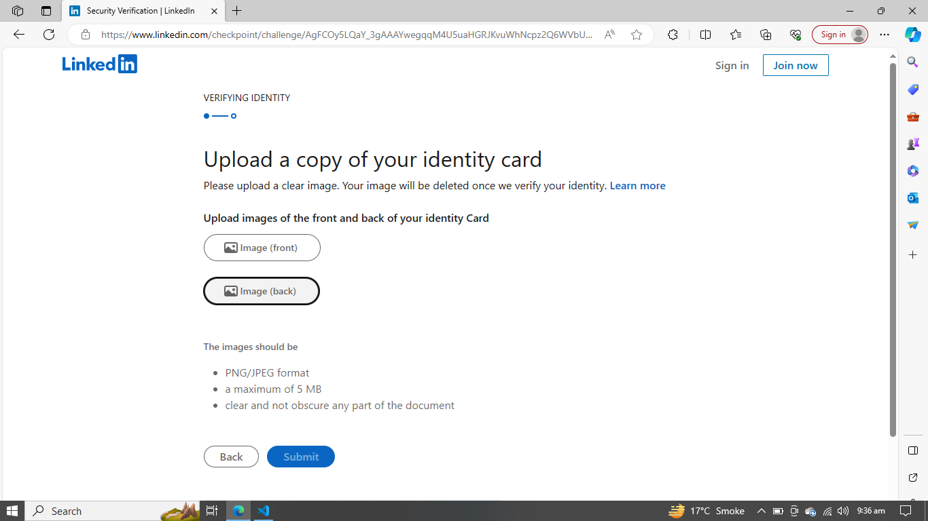



[Ahmer Arman - YouTube](https://www.youtube.com/@ahmerarman/community)

[Ahmer Arman - YouTube](https://www.youtube.com/@ahmerarman/community)

[Ahmer Arman - YouTube](https://www.youtube.com/@ahmerarman/community)



*import* React *from* 'react'

const *page* =()=>{

*return* (

<div>

<div *className*="flex mx-5  my-7 justify-between" *bg-grey-300* *rounded-2x1* *p-3* *rounded-full* *justify-around* *justify-*>

        <div *className*="bg-red-100">Home</div>

        <div *className*="bg-orange-100">About Us</div>

        <div *className*="bg-green-100">Contact Us</div>

        <div *className*="bg-green-100">Dashboard</div>

       </div>

</div>

)

}

*export* *default* page

*import* React *from* 'react'

const *page* =()=>{

*return* (

<div>

<div *className*="flex mx-5  my-7 justify-between" *bg-grey-300* *rounded-2x1* *p-3* *rounded-full* *justify-around* *justify-evenly*>

        <div *className*="bg-red-100">Home</div>

        <div *className*="bg-orange-100">About Us</div>

        <div *className*="bg-green-100">Contact Us</div>

        <div *className*="bg-green-100">Dashboard</div>

       </div>

</div>

)

}

*export* *default* page

*import* React *from* 'react'

const *page* =()=>{

*return* (

<div>

<div *className*="flex mx-5  my-7 justify-between" *bg-grey-300* *rounded-2x1* *p-3* *rounded-full* *justify-around* *justify-evenly*>

        <div *className*="bg-red-100">Home</div>

        <div *className*="bg-orange-100">About Us</div>

        <div *className*="bg-green-100">Contact Us</div>

        <div *className*="bg-green-100">Dashboard</div>

       </div>

</div>

)

}

*export* *default* page

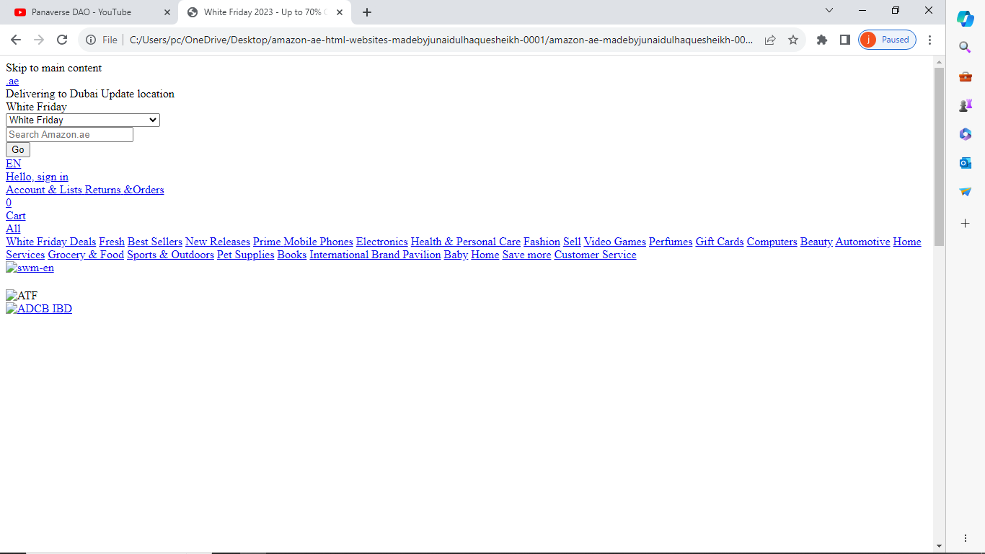



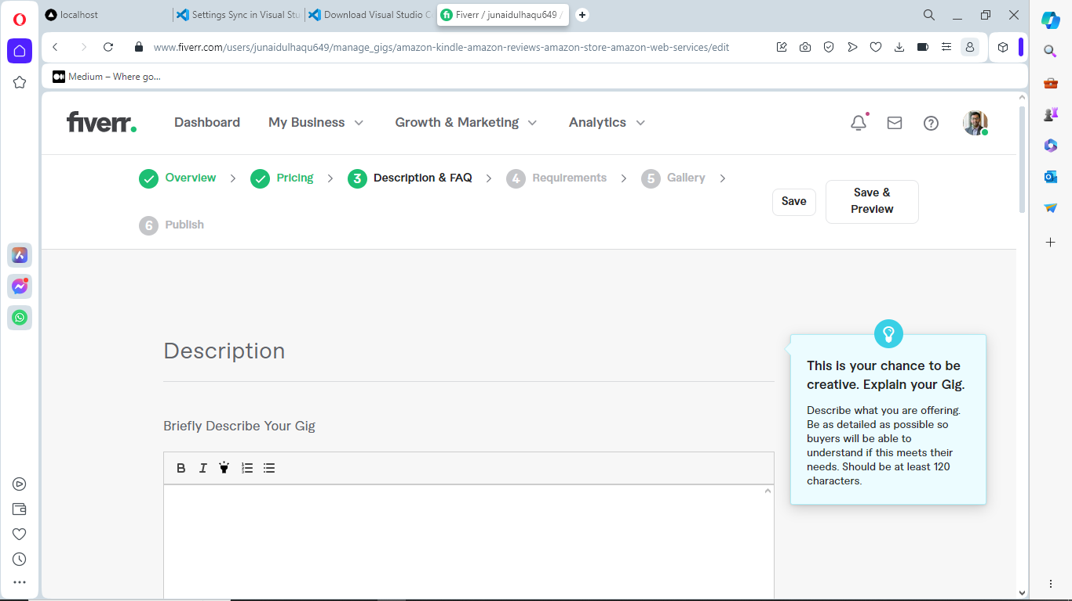

[Fiverr / junaidulhaqu649 / Edit Gig](https://www.fiverr.com/users/junaidulhaqu649/manage_gigs/amazon-kindle-amazon-reviews-amazon-store-amazon-web-services/edit?wizard=2&tab=faq_description)

[Fiverr / junaidulhaqu649 / Edit Gig](https://www.fiverr.com/users/junaidulhaqu649/manage_gigs/amazon-kindle-amazon-reviews-amazon-store-amazon-web-services/edit?wizard=2&tab=faq_description)

[Fiverr / junaidulhaqu649 / Edit Gig](https://www.fiverr.com/users/junaidulhaqu649/manage_gigs/amazon-kindle-amazon-reviews-amazon-store-amazon-web-services/edit?wizard=2&tab=faq_description)

[Fiverr / junaidulhaqu649 / Edit GigFiverr / junaidulhaqu649 / Edit Gig](https://www.fiverr.com/users/junaidulhaqu649/manage_gigs/amazon-kindle-amazon-reviews-amazon-store-amazon-web-services/edit?wizard=2&tab=faq_description)



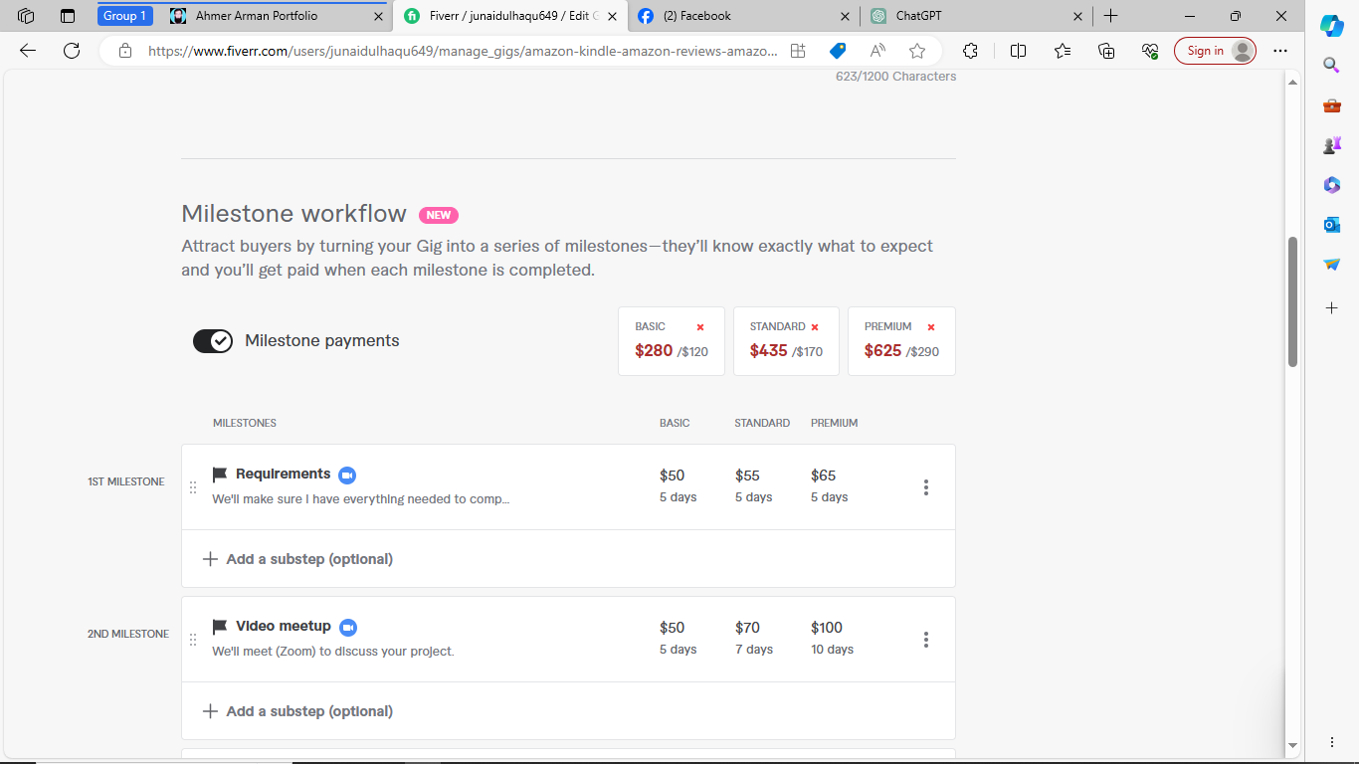

[Fiverr / junaidulhaqu649 / Edit Gig](https://www.fiverr.com/users/junaidulhaqu649/manage_gigs/amazon-kindle-amazon-reviews-amazon-store-amazon-web-services/edit?wizard=1)[Fiverr / junaidulhaqu649 / Create a new Gig](https://www.fiverr.com/users/junaidulhaqu649/manage_gigs/new?wizard=0&tab=general)

[Fiverr / junaidulhaqu649 / Edit Gig](https://www.fiverr.com/users/junaidulhaqu649/manage_gigs/amazon-kindle-amazon-reviews-amazon-store-amazon-web-services/edit?wizard=1)

[Fiverr / junaidulhaqu649 / Edit Gig](https://www.fiverr.com/users/junaidulhaqu649/manage_gigs/amazon-kindle-amazon-reviews-amazon-store-amazon-web-services/edit?wizard=1)

[Fiverr / junaidulhaqu649 / Edit Gig](https://www.fiverr.com/users/junaidulhaqu649/manage_gigs/amazon-kindle-amazon-reviews-amazon-store-amazon-web-services/edit?wizard=1)

[Fiverr / junaidulhaqu649 / Create a new Gig](https://www.fiverr.com/users/junaidulhaqu649/manage_gigs/new?wizard=0&tab=general)

[Fiverr / junaidulhaqu649 / Create a new Gig](https://www.fiverr.com/users/junaidulhaqu649/manage_gigs/new?wizard=0&tab=general)

[Fiverr / junaidulhaqu649 / Create a new GigFiverr / junaidulhaqu649 / Create a new GigFiverr / junaidulhaqu649 / Create a new GigFiverr / junaidulhaqu649 / Create a new GigFiverr / junaidulhaqu649 / Create a new GigFiverr / junaidulhaqu649 / Create a new GigFiverr / junaidulhaqu649 / Create a new GigFiverr / junaidulhaqu649 / Create a new GigFiverr / junaidulhaqu649 / Create a new GigFiverr / junaidulhaqu649 / Create a new GigFiverr / junaidulhaqu649 / Create a new GigFiverr / junaidulhaqu649 / Create a new GigFiverr / junaidulhaqu649 / Create a new GigFiverr / junaidulhaqu649 / Create a new GigFiverr / junaidulhaqu649 / Create a new GigFiverr / junaidulhaqu649 / Create a new GigFiverr / junaidulhaqu649 / Create a new GigFiverr / junaidulhaqu649 / Create a new GigFiverr / junaidulhaqu649 / Create a new GigFiverr / junaidulhaqu649 / Create a new GigFiverr / junaidulhaqu649 / Create a new GigFiverr / junaidulhaqu649 / Create a new GigFiverr / junaidulhaqu649 / Create a new GigFiverr / junaidulhaqu649 / Create a new GigFiverr / junaidulhaqu649 / Create a new GigFiverr / junaidulhaqu649 / Create a new GigFiverr / junaidulhaqu649 / Create a new GigFiverr / junaidulhaqu649 / Create a new GigFiverr / junaidulhaqu649 / Create a new GigFiverr / junaidulhaqu649 / Create a new GigFiverr / junaidulhaqu649 / Create a new GigFiverr / junaidulhaqu649 / Create a new GigFiverr / junaidulhaqu649 / Create a new GigFiverr / junaidulhaqu649 / Create a new GigFiverr / junaidulhaqu649 / Create a new GigFiverr / junaidulhaqu649 / Create a new GigFiverr / junaidulhaqu649 / Create a new GigFiverr / junaidulhaqu649 / Create a new GigFiverr / junaidulhaqu649 / Create a new GigFiverr / junaidulhaqu649 / Create a new GigFiverr / junaidulhaqu649 / Create a new GigFiverr / junaidulhaqu649 / Create a new GigFiverr / junaidulhaqu649 / Create a new Gig](https://www.fiverr.com/users/junaidulhaqu649/manage_gigs/new?wizard=0&tab=general)=======

